**IBM Smart Interns Data Analytics Project**

**Plugging into The Future: An Exploration of Electricity Consumption Patterns**

**Team Members:**

1. **Brindha .S brindha.21ads@sonatech.ac.in**
2. **Vishva Helina .J vishvahelina.21ads@sonatech.ac.in**
3. **Harihara Sudhan .R hariharasuhan.21ads@sonatech.ac.in**

**Problem Understanding**

In the context of this data analytics project, the core focus is on comprehending the intricate electricity consumption patterns in India, specifically during the years 2019 and 2020. The fundamental question that propels this investigation is how the implementation of a nationwide lockdown, particularly between March and June 2020, impacted the prevailing trends in electricity usage. By diving deep into historical consumption data and juxtaposing it against the unprecedented backdrop of the lockdown, the project seeks to unearth pivotal insights and correlations that shed light on the nuanced relationship between societal dynamics and energy consumption.

* **Business Problem**

The primary business problem is to understand the influence of the nationwide lockdown on electricity consumption in India. This involves identifying consumption variations across states, examining the extent of the impact, and uncovering any insights that could guide energy policies or resource allocation during future disruptions.

* **Business Requirements**
* Analyze the electricity consumption data for both 2019 and 2020 to uncover trends and patterns.
* Specifically, focus on the period of the lockdown (March to June 2020) and identify any anomalies.
* Highlight regions or states with notable deviations in consumption.
* Communicate the findings through compelling data visualizations and a coherent narrative.
* **Literature Survey**

A comprehensive review of existing literature and similar studies revealed that external factors, such as lockdowns, have the potential to significantly impact energy consumption patterns. These studies emphasized the importance of analyzing industrial activities as a key driver behind consumption fluctuations during exceptional events.

* **Social or Business Impact**

Understanding the correlation between the lockdown and electricity consumption can have profound implications for various sectors. It can guide policymakers in making informed decisions about energy resource management, infrastructure planning, and resilience strategies. Furthermore, it sheds light on the adaptability of the energy sector during unforeseen disruptions.

**Data Collection & Extraction from Database**

* The dataset used in this project was sourced from Kaggle and is titled "State-wise Power Consumption in India."
* The dataset encompasses attributes such as date, region, and power consumption (measured in gigawatt-hours).
* **Collect the Dataset**

The dataset was meticulously compiled to encapsulate information on electricity consumption across diverse states in India for both the years 2019 and 2020.

* **Storing Data in Relational Database**

The collected dataset was efficiently stored in a relational database to facilitate streamlined data management, manipulation, and retrieval.

* **Perform SQL Operations**

SQL operations were conducted on the database to ensure data quality. This involved addressing missing values, outliers, and inconsistencies that could affect the integrity of subsequent analyses.

* **Connect Database with Tableau**

Establishing a connection between the relational database and Tableau enabled seamless data transfer and paved the way for subsequent visualization and analysis within the Tableau platform.

**Data Preparation**

Data preparation encompassed a series of steps to ensure the dataset's quality and compatibility with visualization tools.

* **Prepare the Data for Visualization**

Data preparation included normalization and aggregation to create a dataset suitable for creating insightful visualizations.

**Data Visualizations**

Using Tableau, we have created various visualizations to analyze the electricity consumption patterns

**No of Unique Visualizations**: 12

**Page 1** presents a dynamic bar chart that visualizes electricity usage trends by regions. The chart elegantly showcases the relationship between dates (years), distinct regions, and their corresponding electricity usage.

**Tableau link -**

<https://public.tableau.com/app/profile/brindha.s3501/viz/Ibmsmartinternsproject-Electricityconsumption-page1/UsagebyRegions?publish=yes>

**VIDEO 1 :**

<https://drive.google.com/file/d/1_x9GI9_7vK6URHKugjUnB6bhJc4ViXUW/view?usp=drive_link>

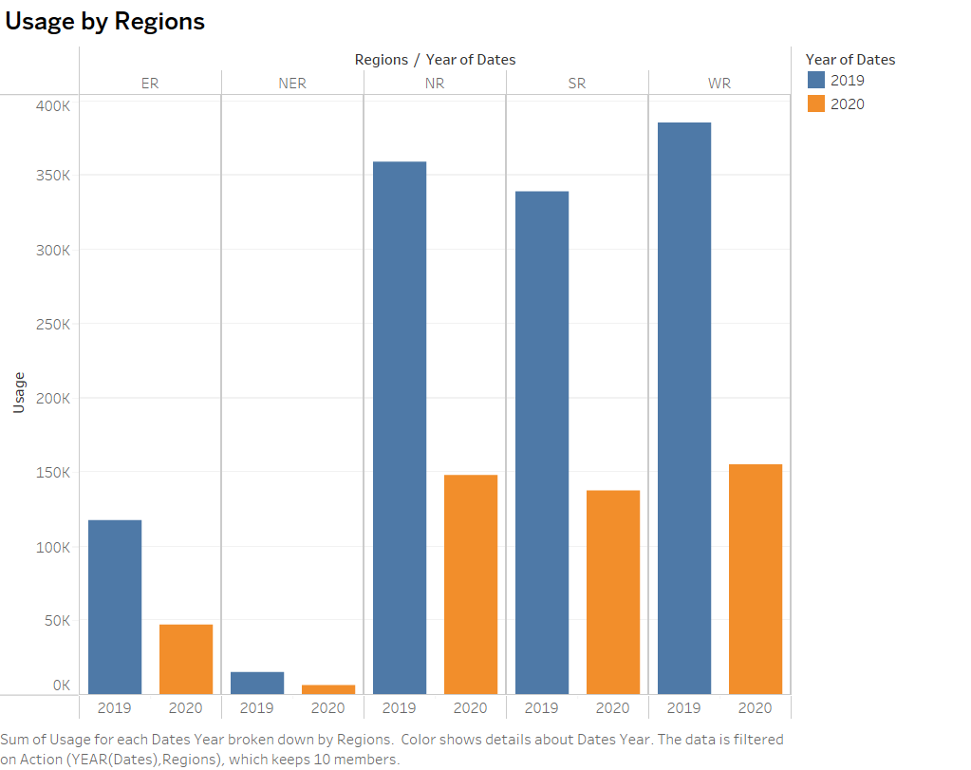

**Page 2** introduces a concise and intuitive pie chart, offering a comprehensive representation of regional electricity usage. The chart distills the complex dataset into a visually digestible format, highlighting the proportional distribution of usage among different regions.

**Tableau link –**

<https://public.tableau.com/app/profile/brindha.s3501/viz/Ibmsmartinternsproject-Electricityconsumption-page2/Piechartrepresentationofregionalusage?publish=yes>

**VIDEO 2**

<https://drive.google.com/file/d/1DnZq3ARuGNKQX7CNZZoBLZtN5t8yqru_/view?usp=drive_link>

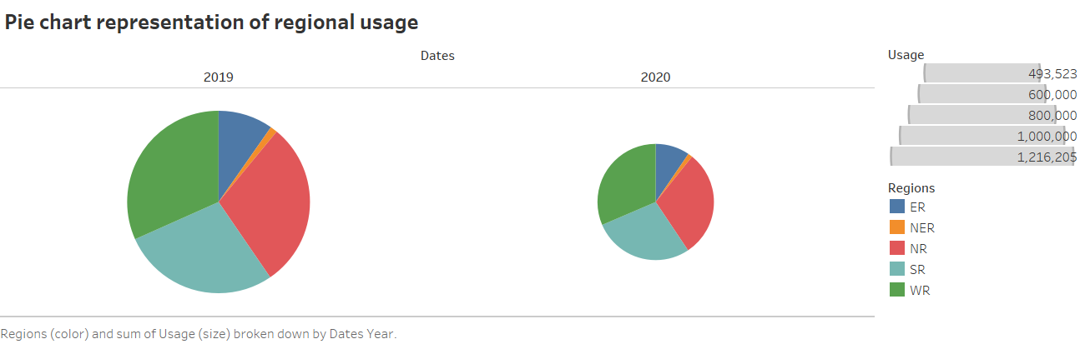

**Page 3** features a comparative line chart that effectively visualizes the differences in electricity consumption between the years 2019 and 2020. The chart highlights the fluctuations in consumption patterns across both years, facilitating a clear understanding of the variations.

**Tableau link –**

<https://public.tableau.com/app/profile/brindha.s3501/viz/Ibmsmartinternsproject-Electricityconsumption-page3/Differencebetween2019and2020?publish=yes>

**VIDEO 3**

<https://drive.google.com/file/d/1iCHVK6z0iqPcnLgDE1guTItkNfgIrNdE/view?usp=drive_link>

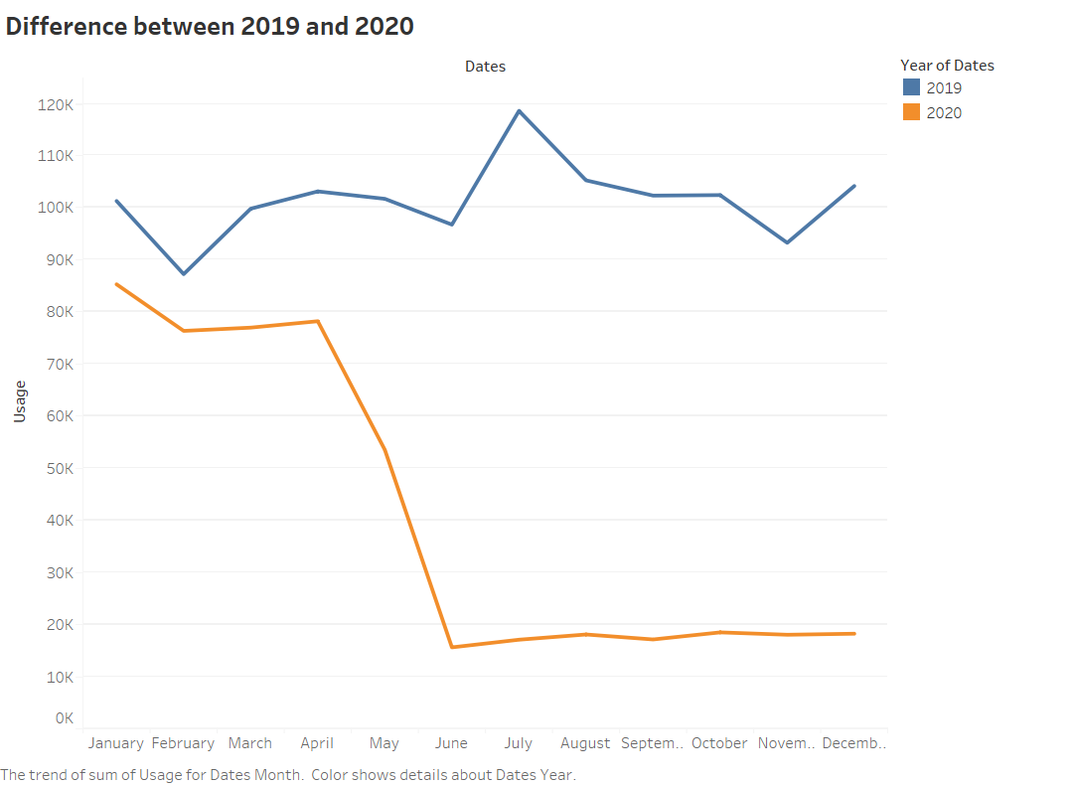

**Page 4** showcases an informative bar chart that portrays the electricity consumption for each state. The chart provides a comprehensive overview of how different states contribute to the overall electricity consumption.

**Tableau link –**

<https://public.tableau.com/app/profile/brindha.s3501/viz/Ibmsmartinternsproject-Electricityconsumption-page4/Stateconsumptions?publish=yes>

**VIDEO 4**

<https://drive.google.com/file/d/1cEI7wkzLIrX9I0rsNmuZS9gcMGeZsObi/view?usp=drive_link>

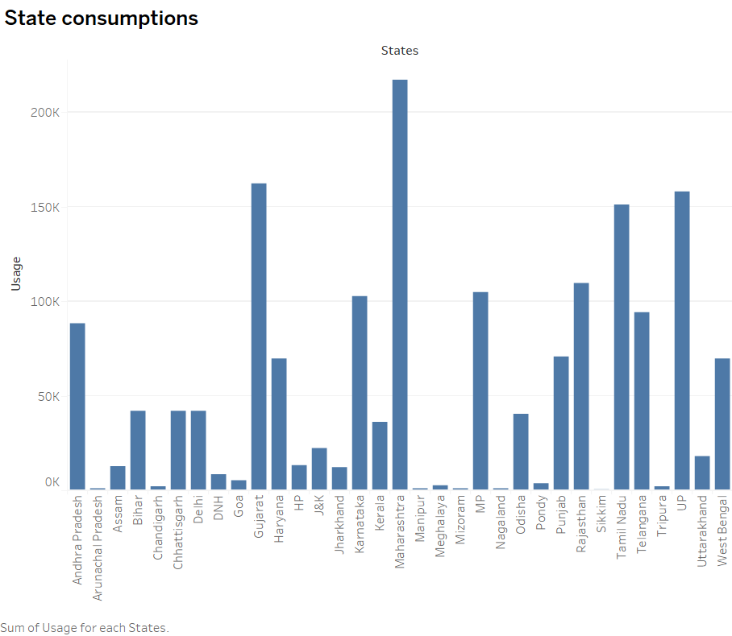

**Page 5** presents an illustrative usage map that effectively communicates the electricity consumption across states in 2019. The variation in color intensity on the India map provides an immediate visual representation of the consumption disparities among different regions

**Tableau link -**

<https://public.tableau.com/app/profile/brindha.s3501/viz/Ibmsmartinternsproject-Electricityconsumption-page5/UsageMapofStatesin2019?publish=yes>

**VIDEO 5**

<https://drive.google.com/file/d/1AmS6L6eODdgm20L3-lzoEkbaJvlgr64w/view?usp=drive_link>

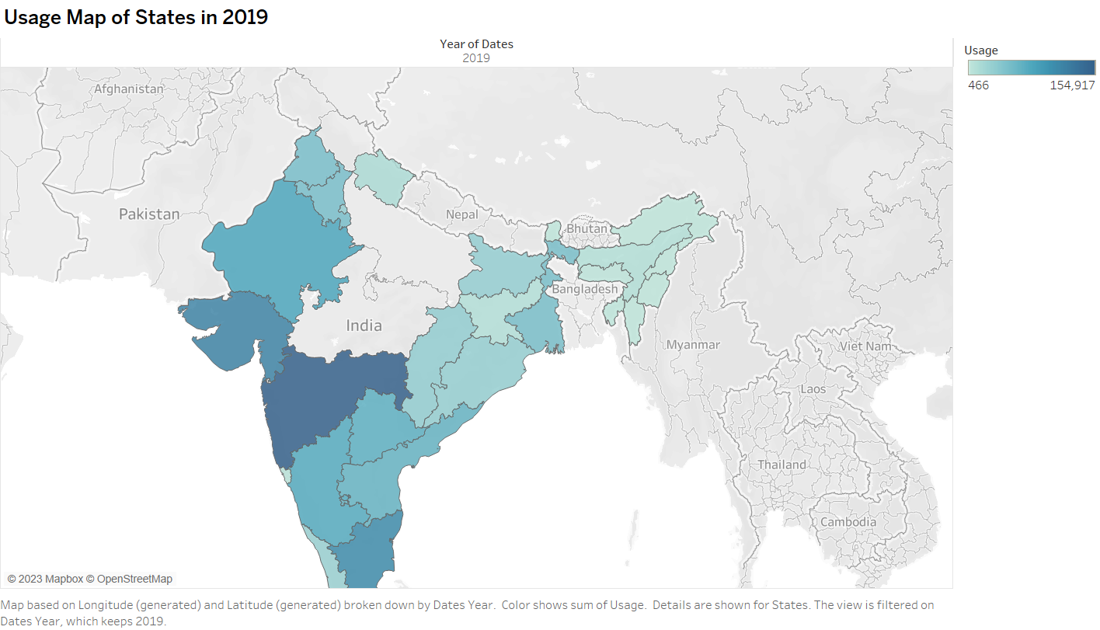

**Page 6** introduces a usage map that visually conveys the electricity consumption patterns across states in the year 2020. The variation in color intensity on the map offers an immediate visual insight into the differing levels of consumption across regions.

**Tableau link –**

<https://public.tableau.com/app/profile/brindha.s3501/viz/Ibmsmartinternsproject-Electricityconsumption-page6/UsageMapofStatesin2020?publish=yes>

**VIDEO 6**

<https://drive.google.com/file/d/17Ttoe-kBaXbchKLSHvaPPZf2LcoZV4HX/view?usp=drive_link>

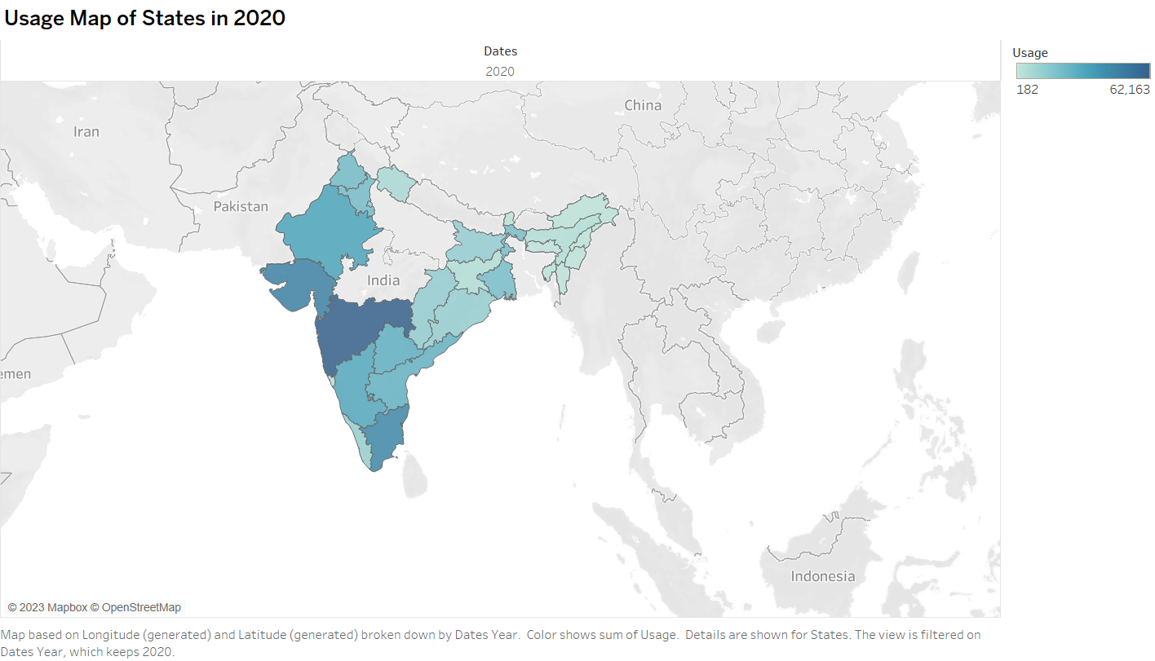

**Page 7** displays a concise bar chart highlighting the top 7 states with the highest electricity consumption in the year 2019. The chart provides a clear snapshot of the states that contributed significantly to the overall consumption.

**Tableau link –**

<https://public.tableau.com/app/profile/brindha.s3501/viz/Ibmsmartinternsproject-Electricityconsumption-page7/Top7stateconsumptionin2019?publish=yes>

**VIDEO 7**

<https://drive.google.com/file/d/1R_tltH7PGtpNFVWa0K3kLjnsFy7o00lb/view?usp=drive_link>

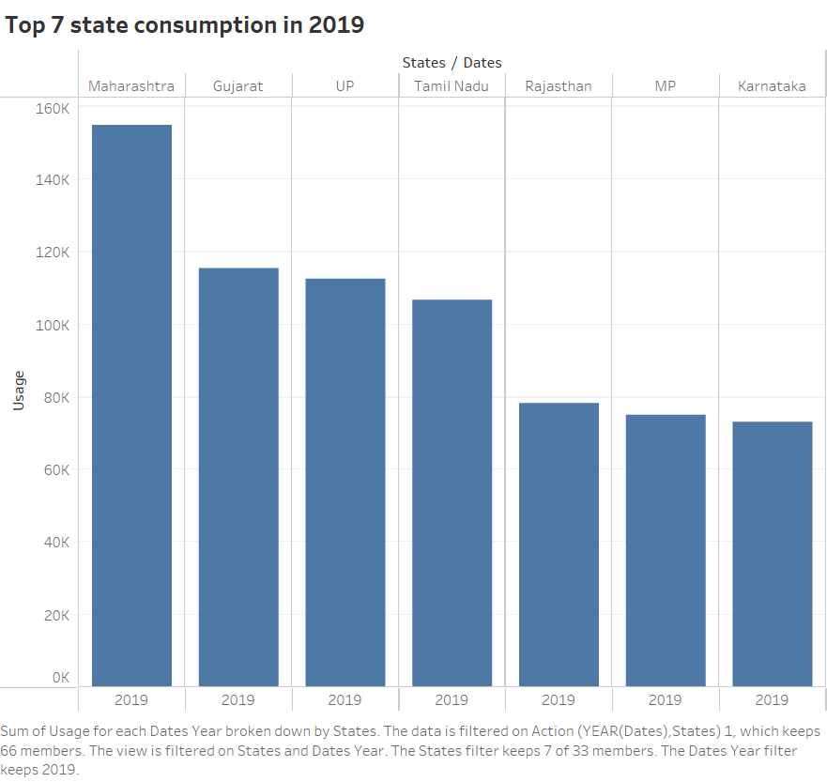

**Page 8** presents a succinct bar graph that highlights the top 7 states with the highest electricity consumption in the year 2020. This graph provides a quick visual comparison of the states that were most influential in shaping consumption patterns during the year.

**Tableau link –**

<https://public.tableau.com/app/profile/brindha.s3501/viz/Ibmsmartinternsproject-Electricityconsumption-page8/Top7stateconsumptionin2020?publish=yes>

**VIDEO 8**

<https://drive.google.com/file/d/1lR80hEYWi6UOI2H5Wyy1FwaN_RWTVOjg/view?usp=drive_link>

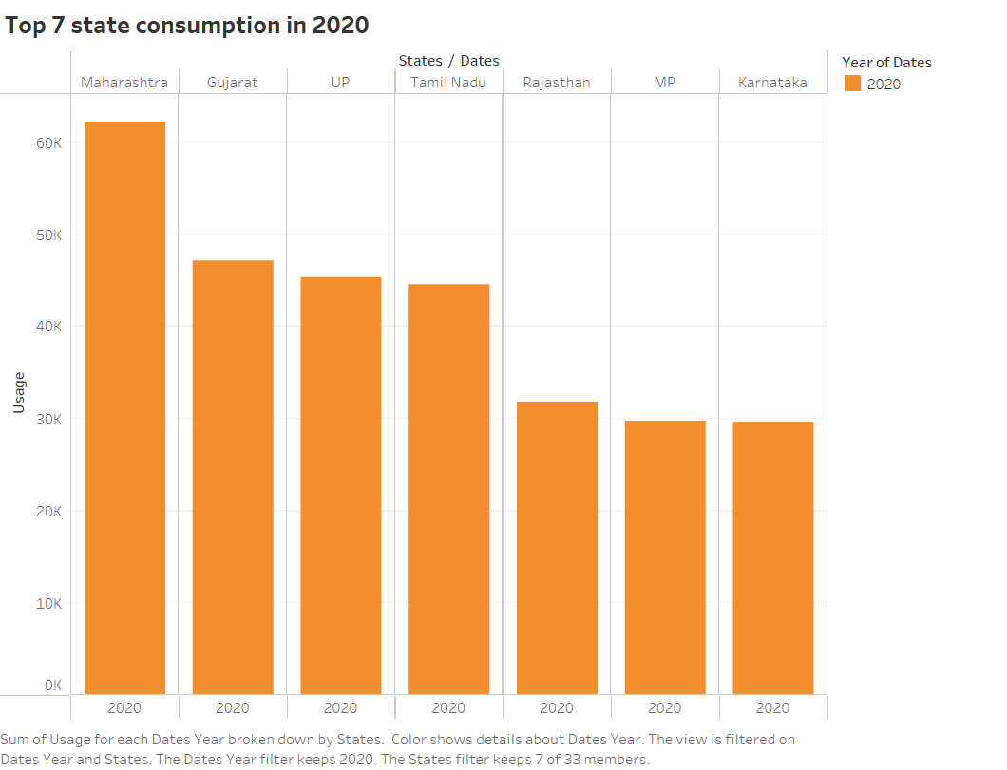

**Page 9** displays a compelling line chart that vividly captures the significant fall in electricity consumption during the year 2020. This chart provides a visual representation of the extent to which consumption declined over the course of the year.

**Tableau link –**

<https://public.tableau.com/app/profile/brindha.s3501/viz/Ibmsmartinternsproject-Electricityconsumption-page9/Fallin2020?publish=yes>

**VIDEO 9**

<https://drive.google.com/file/d/1HLmRTa0pqLwJSJVM-fCExUrtz0OPAfJp/view?usp=drive_link>

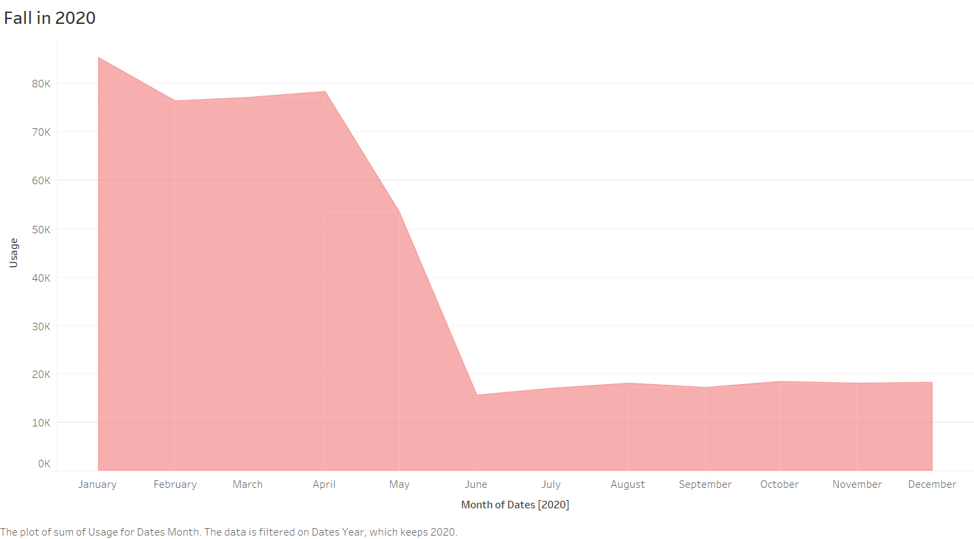

**Page 10** introduces a concise bar chart that effectively illustrates the decline in electricity consumption specifically during the lockdown period. The chart provides a visual overview of how consumption levels dropped during this critical timeframe.

**Tableau link –**

<https://public.tableau.com/app/profile/brindha.s3501/viz/Ibmsmartinternsproject-Electricityconsumption-page10/Fallduringlockdownperiod?publish=yes>

**VIDEO 10**

<https://drive.google.com/file/d/1HQkvOdfmoDXl4G0Mn_ZOIpoIIGTGEeX3/view?usp=drive_link>

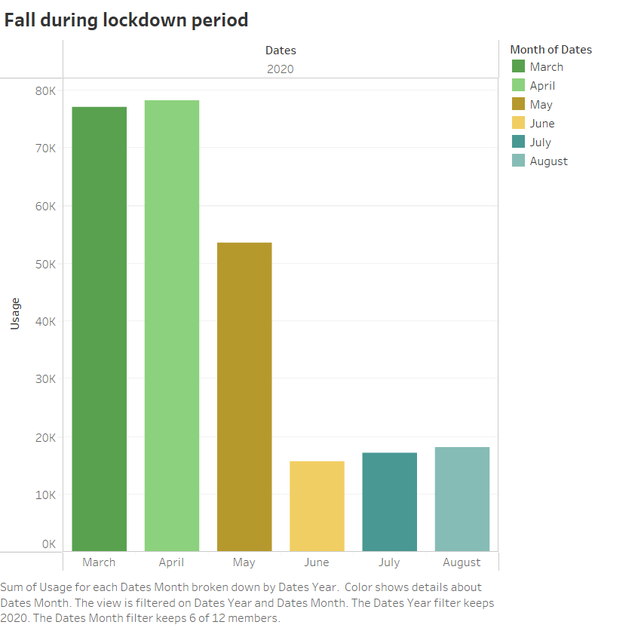

**Page 11** features a visually informative heat map that highlights the reduced electricity usage throughout 2020. This heat map provides a comprehensive visual overview of the specific months and regions where the reduction in consumption was most pronounced.

**Tableau link –**

<https://public.tableau.com/app/profile/brindha.s3501/viz/Ibmsmartinternsproject-Electricityconsumption-page11/Reducedusagein2020?publish=yes>

**VIDEO 11**

<https://drive.google.com/file/d/1hru3VHQbJaPyl1ILo7KTBrc90sxsi7z9/view?usp=drive_link>

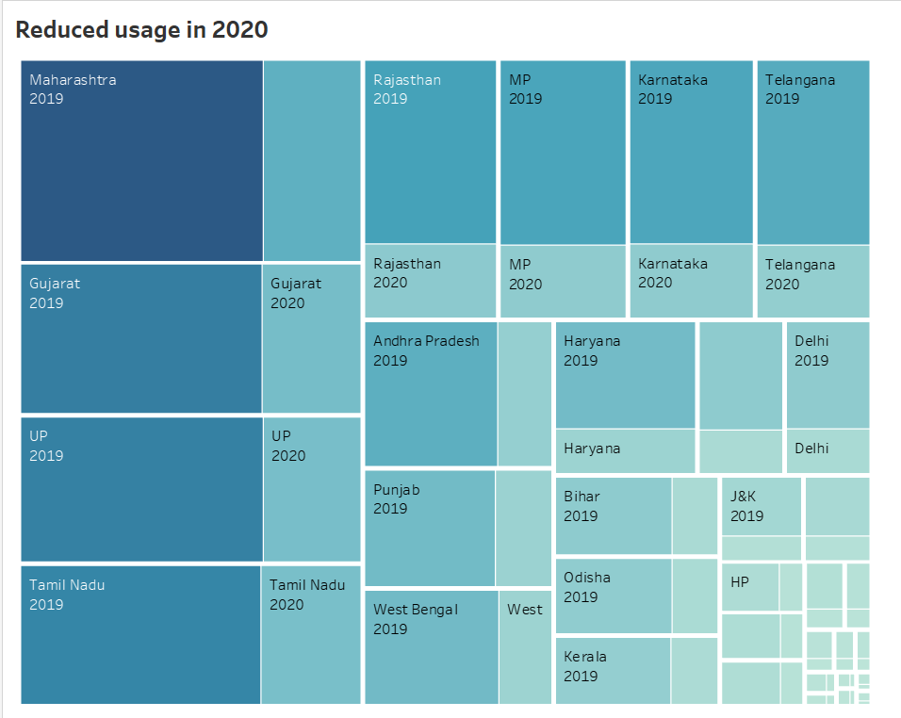

**Page 12** introduces a dynamic packed bubble visualization that showcases the electricity consumption of different states in both 2019 and 2020. This visualization allows for a simultaneous comparison of consumption patterns across the two years.

**Tableau link –**

<https://public.tableau.com/app/profile/brindha.s3501/viz/Ibmsmartinternsproject-Electricityconsumption-page12/Stateconsumptionboth20192020?publish=yes>

**VIDEO 12**

<https://drive.google.com/file/d/1hIY7pfIgVG3BhtsyzHImFzgVOQHIdgSj/view?usp=drive_link>

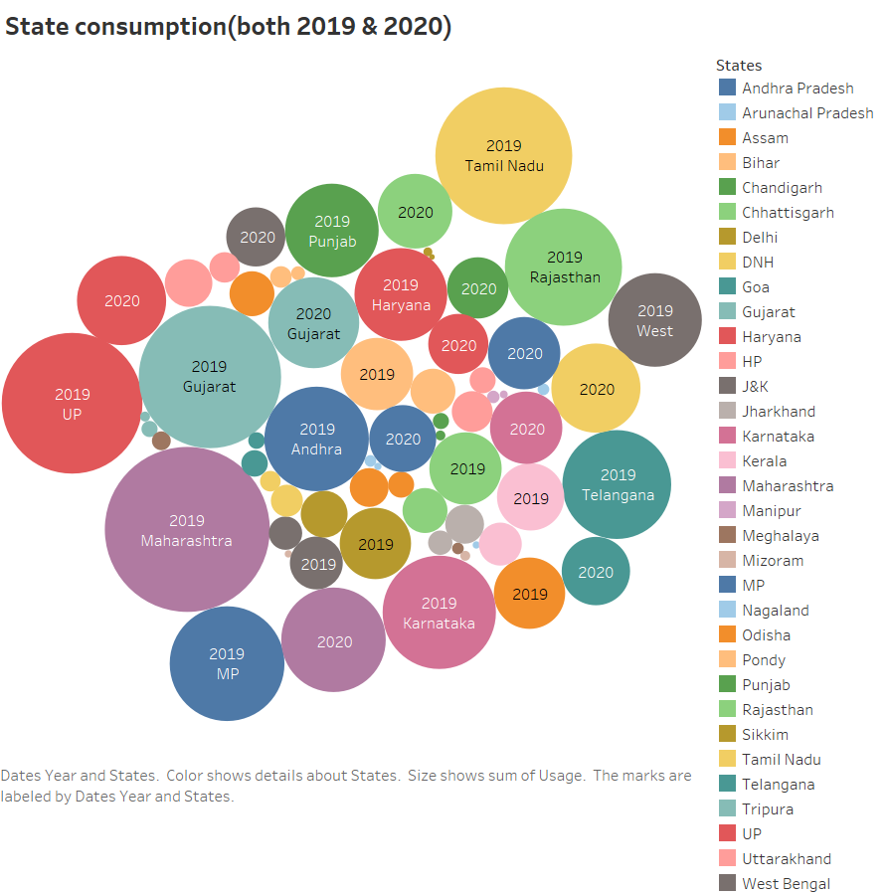

**Dashboard**

The "Dashboard" phase involves the integration of multiple visualizations into a single interface to provide a consolidated and holistic view of the project's insights and findings. This centralized platform allows stakeholders to interact with various visualizations and derive comprehensive insights in one cohesive space.

* **Responsive Design of Dashboard:**

The dashboard was meticulously designed to be responsive, ensuring optimal performance and usability across various devices, including desktops, laptops, tablets, and smartphones.

* **Dashboard Design Considerations**
* **User-Friendly Navigation**: The dashboard's layout and navigation are designed to be intuitive, allowing users to effortlessly switch between different visualizations and sections.
* **Consistent Branding**: The dashboard's design maintains consistent branding elements, such as color schemes and fonts, to create a unified and visually pleasing experience.
* **Data Interactivity**: Interactive elements, such as filters and tooltips, are integrated into the dashboard to enable users to explore specific data points and gain deeper insights.

**Dashboard-1**

The interactive dashboard on this page combines the insightful visualizations from Pages 5, 6, 7, and 8. It seamlessly integrates the usage maps for 2019 and 2020, the top 7 state consumption bar charts for both years, and offers an interactive feature that enables users to interactively highlight states on the map and observe their corresponding consumption in the bar chart."

**Tableau link –**

<https://public.tableau.com/app/profile/brindha.s3501/viz/Ibmsmartinternsproject-Electricityconsumption-dash1/Dashboard1?publish=yes>

**Dashboard 1**

<https://drive.google.com/file/d/1aRuv1Ma0R-SjqZdXMdErcMEUTDleFmp0/view?usp=drive_link>

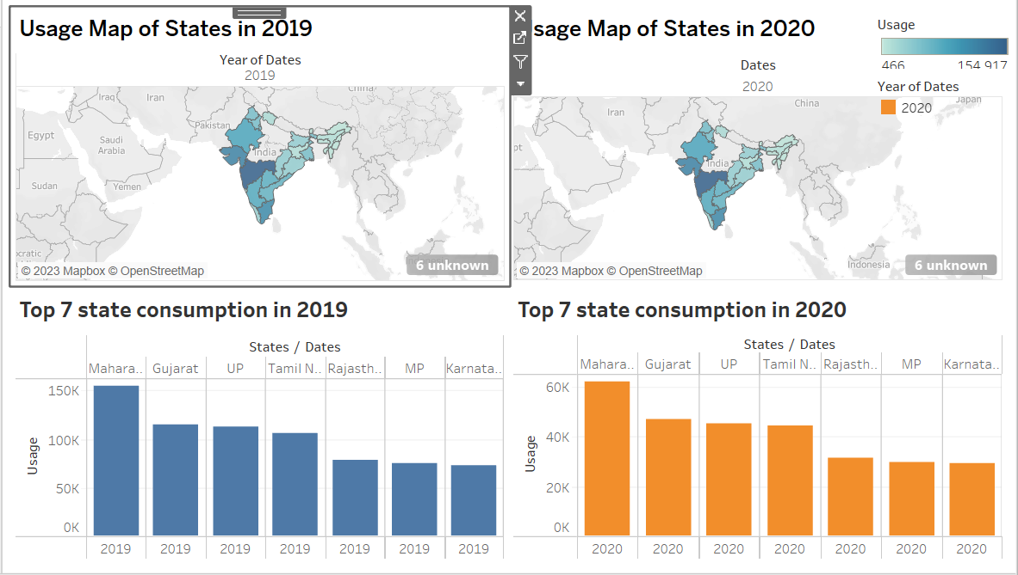

**Dashboard- 2**

The second interactive dashboard presented here combines the insightful visualizations from Pages 1 and 2. It seamlessly integrates the bar chart depicting usage by regions and the pie chart illustrating regional consumption distribution. This dashboard also offers an interactive feature that allows users to select a region on the bar chart to highlight it in the pie chart.

**Tableau link –**

<https://public.tableau.com/app/profile/brindha.s3501/viz/Ibmsmartinternsproject-Electricityconsumption-dash2/Dashboard2?publish=yes>

**Dashboard 2**

<https://drive.google.com/file/d/1qW8VeGZ8AngXqAmvDRZ4TqbADDQoCPHD/view?usp=drive_link>

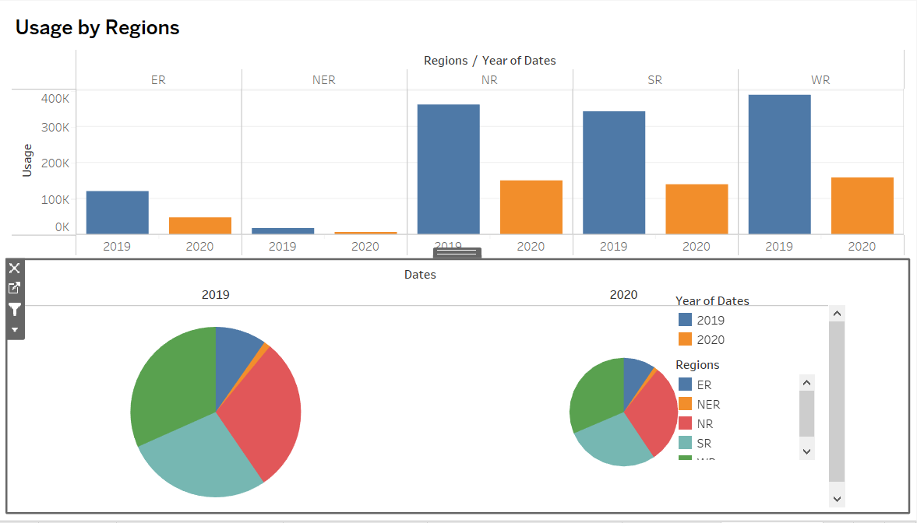

**Story**

To communicate the findings effectively, I created a storytelling component in Tableau. The storytelling feature allowed me to weave together different visualizations and insights into a cohesive narrative. The story emphasized the impact of the lockdown on electricity consumption and highlighted the variations between states.

**Emphasizing the Lockdown's impact and State-Level variations:** The storytelling component places a specific emphasis on highlighting the impact of the nationwide lockdown on electricity consumption patterns. It aims to unravel how the lockdown affected energy demand, whether there were discernible trends or anomalies, and what implications these changes held.

**Story's Structure**

* **Introduction**: The story commences with an introduction that contextualizes the project's purpose and the central theme of analyzing electricity consumption patterns in India during 2019 and 2020.
* **Lockdown's Impact**: The narrative then delves into the impact of the nationwide lockdown on electricity consumption. It discusses the motivation behind studying the lockdown period, the anticipated changes, and potential causal factors.
* **Visual Insights**: The story integrates key visualizations, each accompanied by concise explanations. These visualizations elucidate consumption trends, state-level variations, and specific consumption changes during the lockdown.
* **Highlighting Anomalies**: The narrative draws attention to any notable anomalies or deviations discovered in the data, emphasizing their significance in understanding the lockdown's effect.
* **Concluding Insights**: The story concludes by summarizing the project's key findings, insights, and implications. It underscores the relevance of the study's outcomes for energy planning, resilience strategies, and policy-making.

**Story-**

<https://public.tableau.com/app/profile/brindha.s3501/viz/Ibmsmartinternsproject-Electricityconsumption-story/Story2?publish=yes>

**Performance Testing**

To guarantee a smooth user experience, the performance of visualizations was thoroughly tested, focusing on loading times and responsiveness.

* **Amount of Data Rendered to DB**

Only the essential subsets of data required for visualization were processed.

* **Utilization of Data Filters**

Interactive data filters were integrated to empower users to explore specific timeframes and regions within the visualizations.

* **No of Calculation Fields:** 2 Fields
* **No of Visualizations/Graphs:** 12 Unique visualisations

**Web Integration:**

The dashboard and storytelling components were seamlessly embedded into a web interface using Flask.

Dashboard and Story Embed with UI With Flask:

Leveraging Flask, the dashboard and storytelling elements were integrated into a user-friendly web interface, enhancing user engagement.

Here comes the preview of our webpages

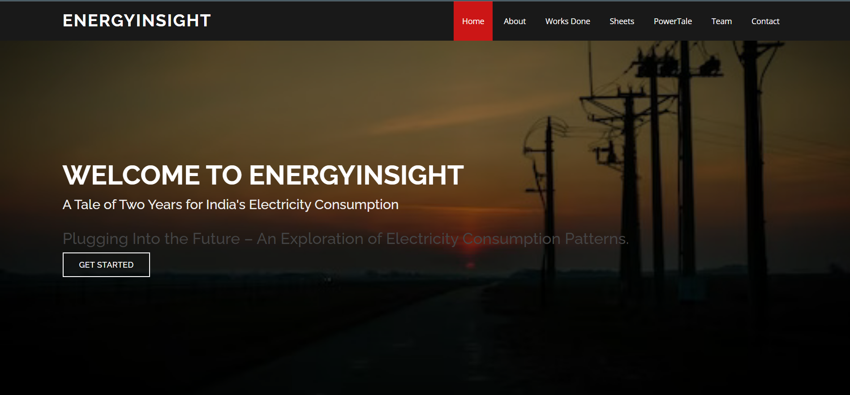

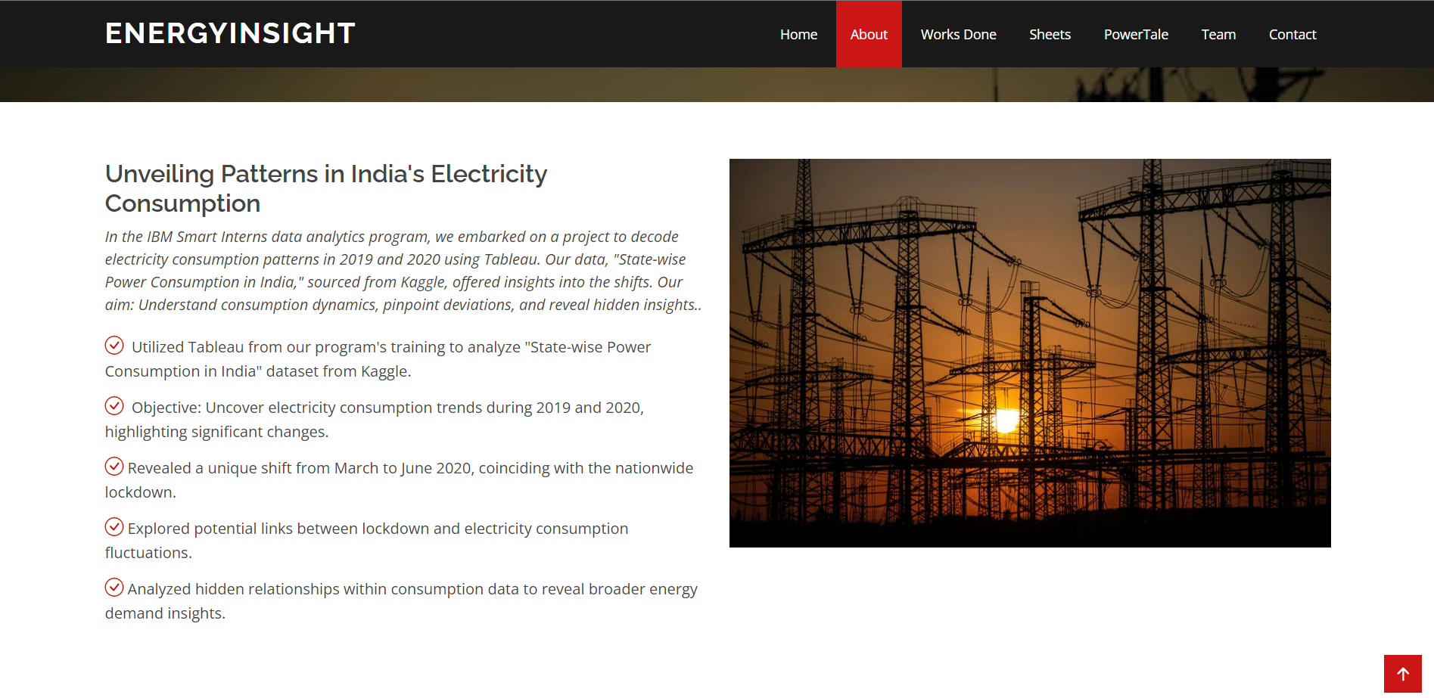

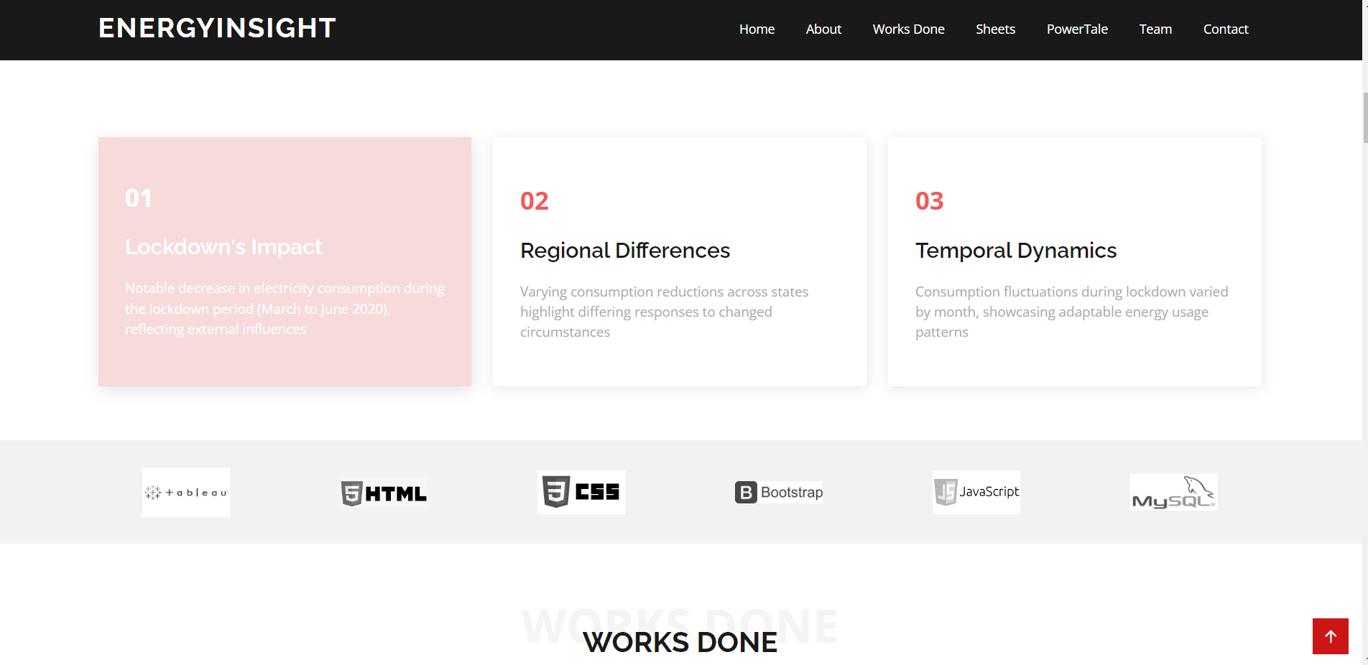

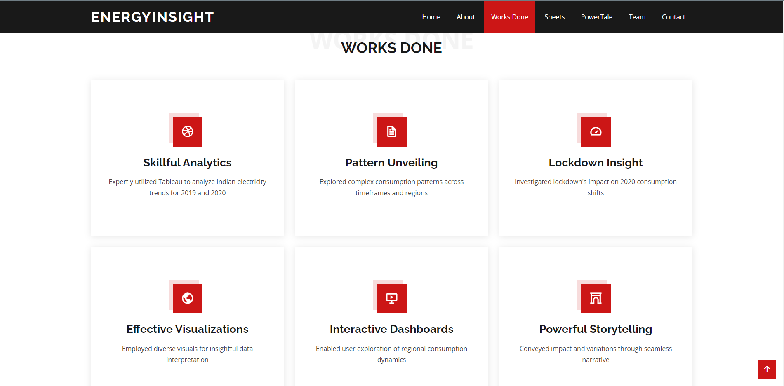

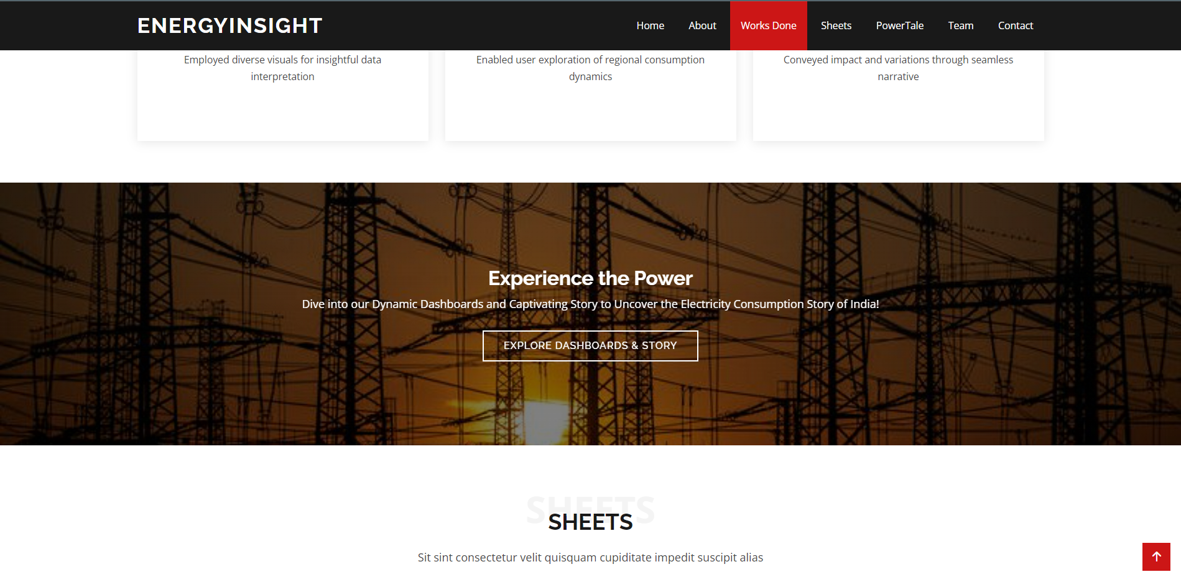

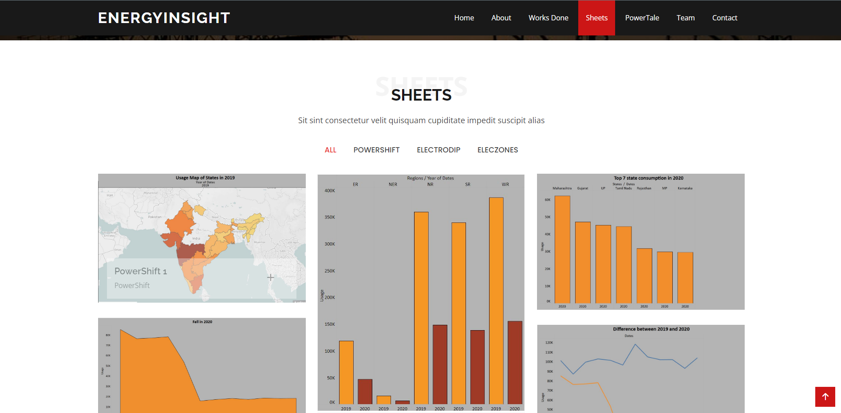

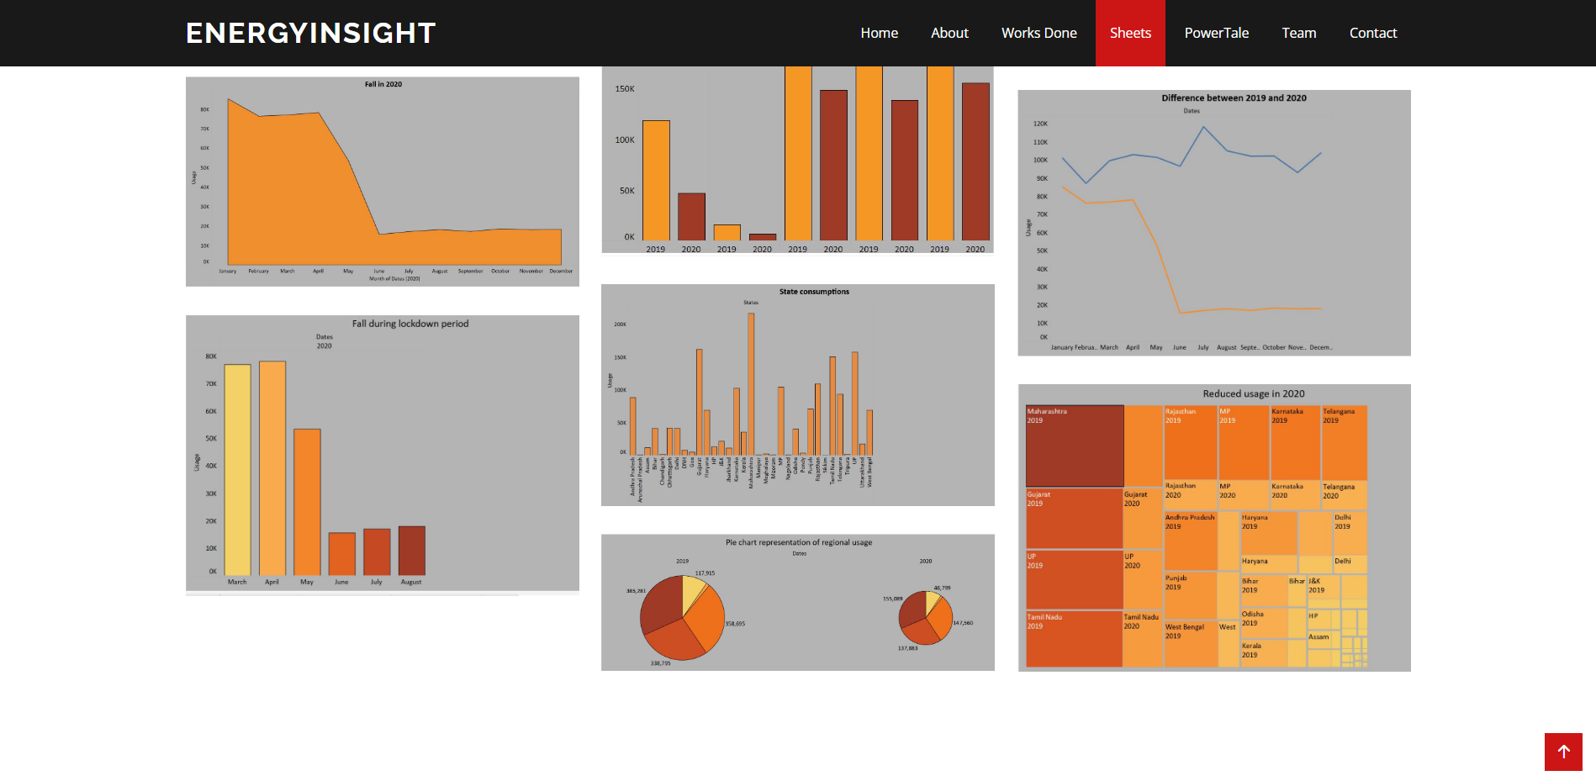

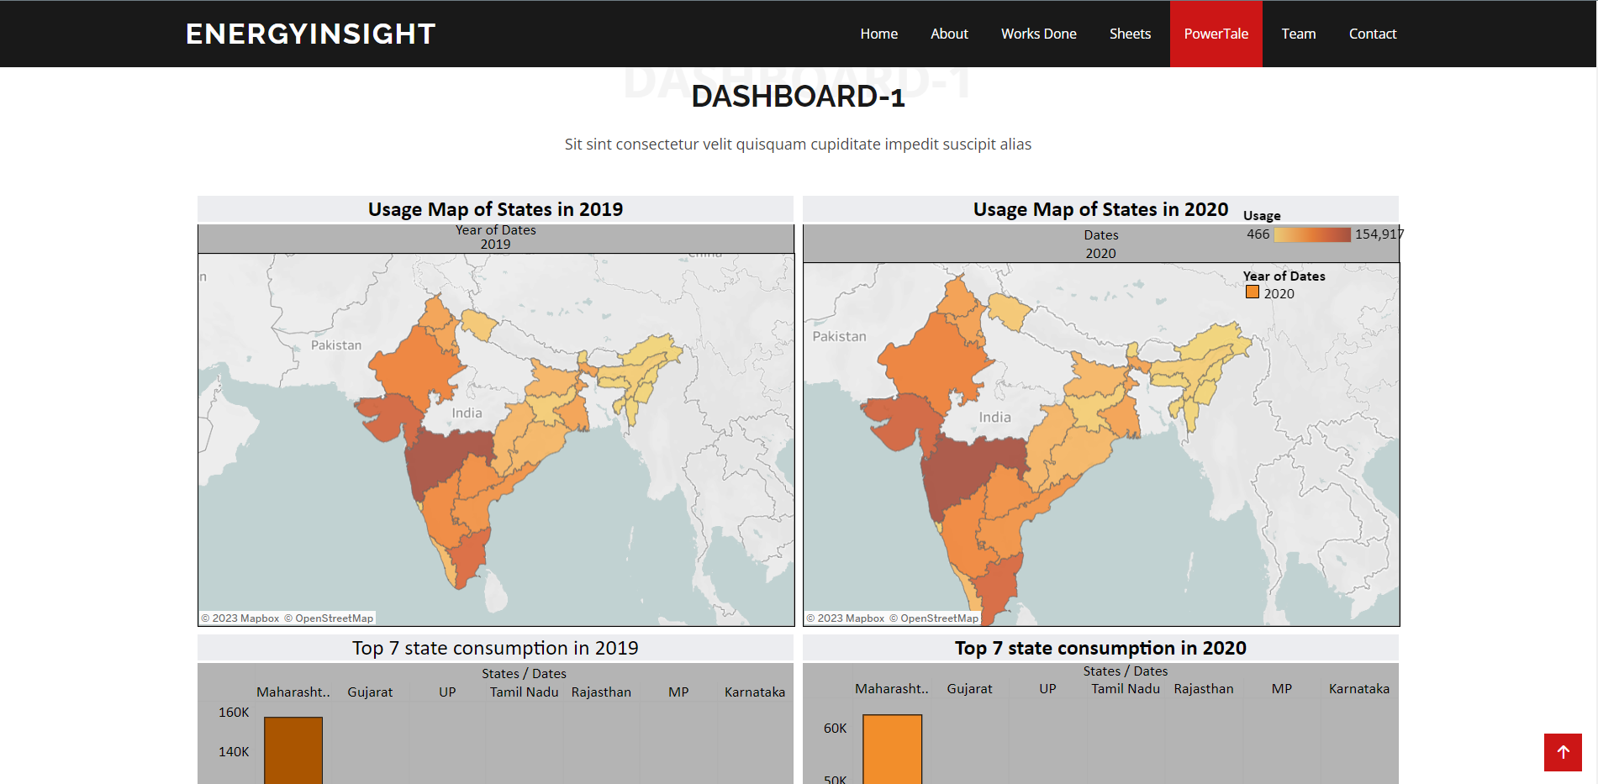

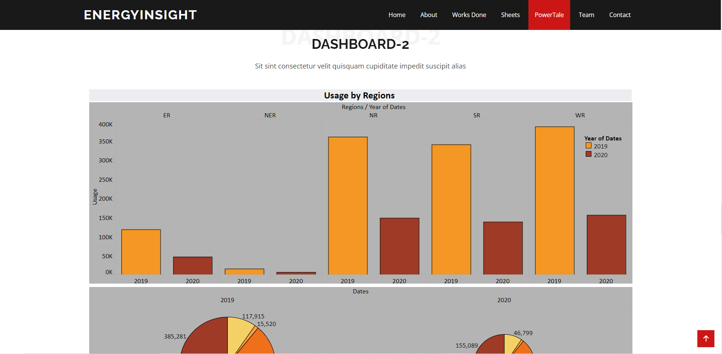

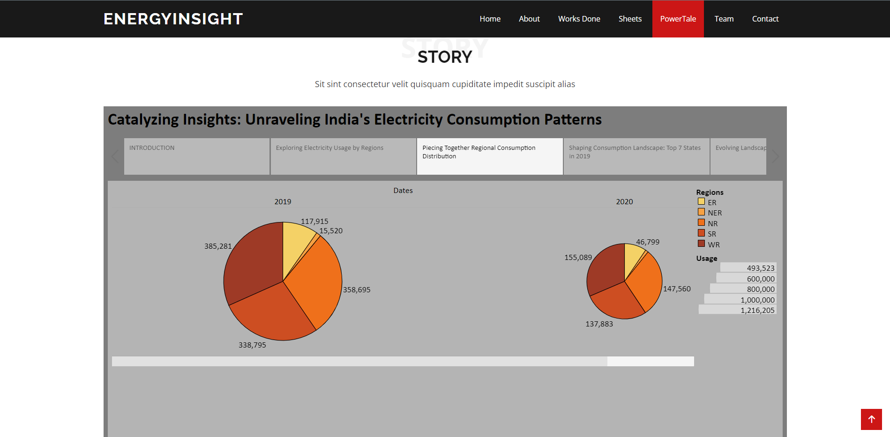

**Project Demonstration & Documentation:**

The project's lifecycle was captured through a comprehensive video demonstration, detailing the end-to-end solution development.

Record Explanation Video:

An explanatory video was produced to showcase the project's progression, from inception to implementation.

<https://drive.google.com/file/d/1jAHafDzGYrAGTVEZvl1MoW1P8Q58wJ5R/view?usp=drive_link>